**(1) Has the online community increased user revenue? (1.5 points) [Nora]**

**Model results:**



**Brainstorming(quantify the effect of introducing the online community):**

1. Here, the difference in difference model is used to test the question.
2. In the regression table above, we can see the term ‘**join*treatment**’ has a positive value and it is significant in statistics (p-value = 0.000253). This means the users who joined the community spend more in the month after joined

The first approach was to calculate/analyze the effect of the online community on revenue by comparing the average change overtime (month) of revenue from those who joined the online community, compared to the average change overtime (month) from those who did not join. We used the Difference in Difference model which gives us …… the result shows that the difference in revenue between the two is $29 which means the users who join the community spend more in the month after they joined. See appendix …

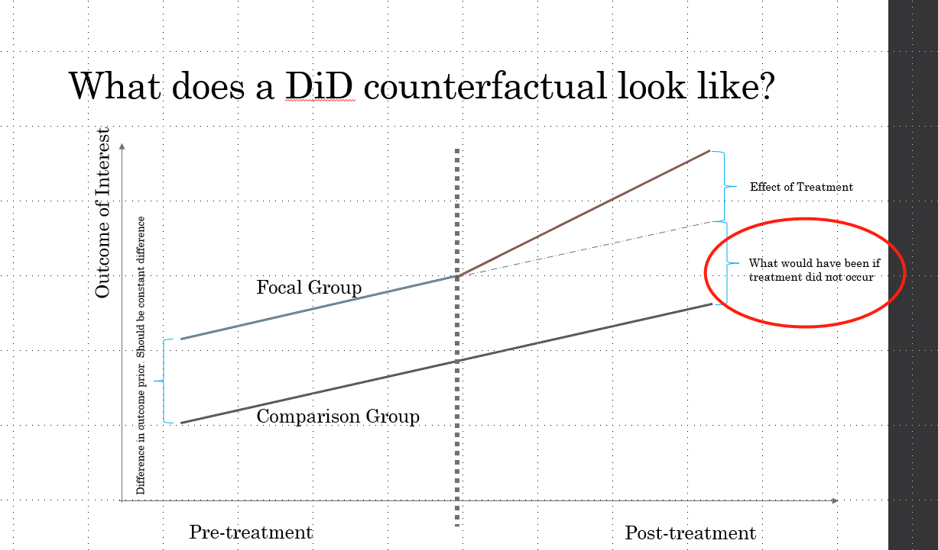

1. Interpreting the $29.01845. Quantify the effect.
   1. $29.01845 = (the revenue after the community launch of the users who joined the community - the revenue before the community launch of the users who joined the community) - (the revenue after the community launch of the users who did not join the community - the revenue before the community launch of the users who did not join the community)

How to interpret the result in biz language：

We excluded the effect of natural growth of users’ spending across time (a month), and just included the effect of treatment(which in this case is whether a user joins the co mmunity). The result shows that if a user joins the community, the spending of this user would increase by 29 dollars in a month.

**Limitation and critical thinking:**

**(2) Has the online community led to increased retention?**

* **Answer: The online community led to decreased retention (1.5 points) [Xingxuan]**

**Model results:**

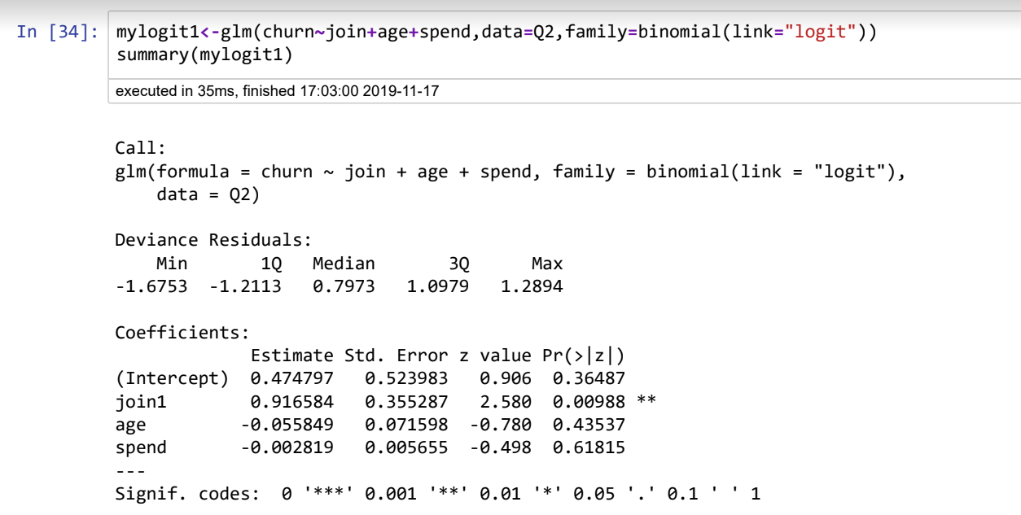

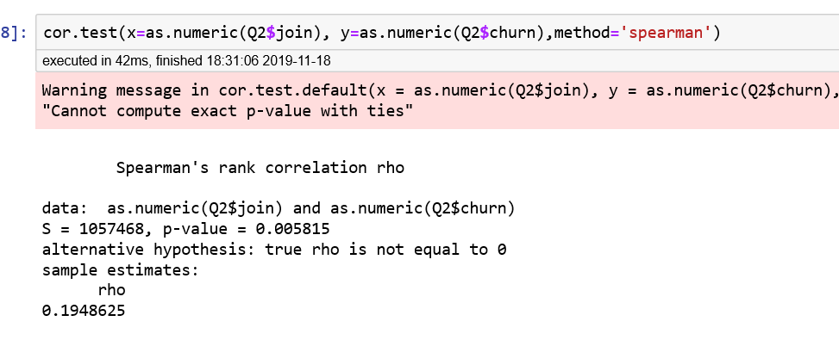

**Brainstorming(quantify the effect of introducing the online community):**

(a)The term ‘join1’ is positive and significant (p-value =0.00988) . This means the users who joined the community are more likely to leave in the 90 days than users who did not join.

(b)interpreting the 0.9165 and its meaning

**Limitation and critical thinking:**

Accuray is only 62.8%

Why joined community decrease retention???

**(3) Has the online community led to an increase in CLV? (Assume a margin of 50% of customer spend) (1.5 points) [Frank]**

**Model results:**

Regression Model:



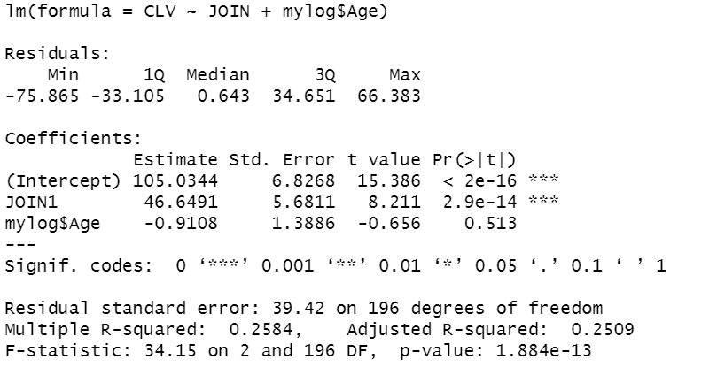

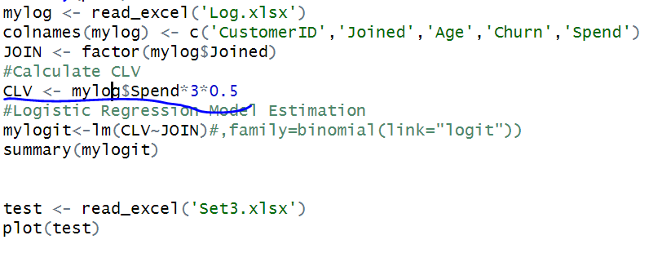



Anova:

It is not normal but has constant variance. So, the wilcox test is used.

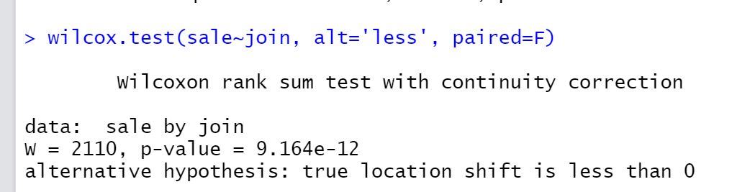

The users who joined community spend more than the users who did not join in the 90 days.

**Brainstorming(quantify the effect of introducing the online community):**

(a)The users who joined community spend more than the users who did not join in the 90 days.

(b) how to interpret the coefficient?

**Limitation and critical thinking:**

1. One major limitation here. The test only shows the users who joined the community spend more than the users who did not. **This correlation does not mean causality**. It is highly possible the users who joined the community are heavy users. They will spend more anyhow whether is a community or not.

**(4) using this new variable, and provide more value to the team. What metrics can you create using this new variable? How would they be useful to the team, CAO or CFO? What new insights might you generate that provide more clarity to this crucial marketing function? (2 points) [Jiangfan]**

**Model results:**

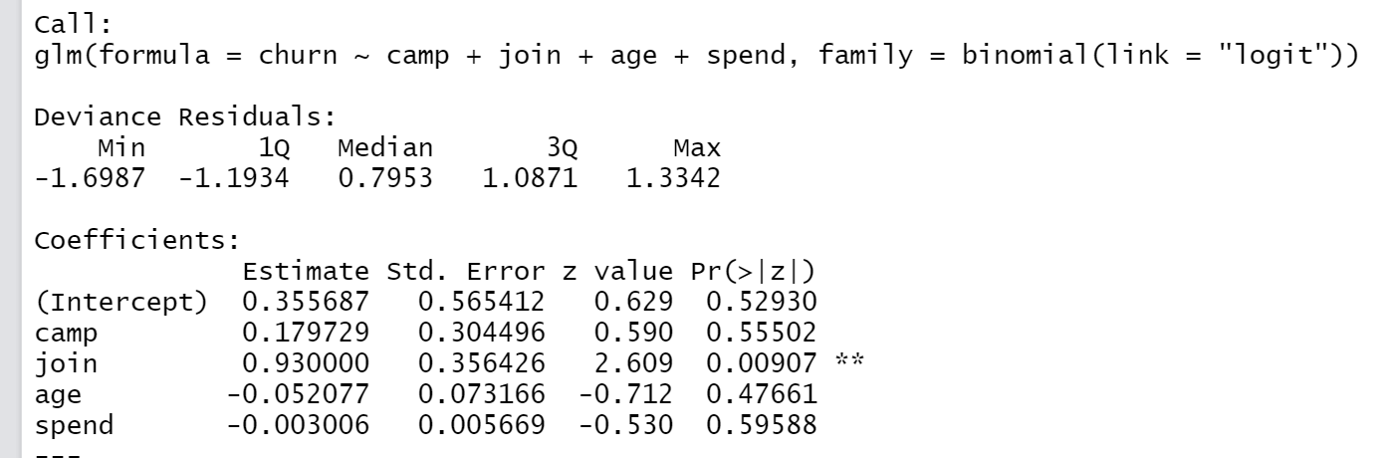

Campaigns has nothing to do with customer retention

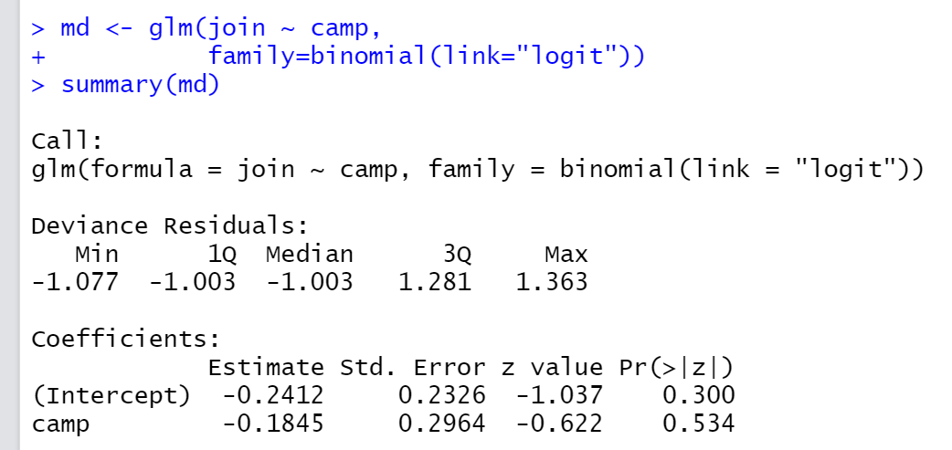

Campaigns has nothing to do with whether join the community

**Brainstorming(quantify the effect of introducing the online community):**

Although campaign has nothing to do with churn or spending. But they are the extra users brought in. Actually increase the firm’s revenue, if acquisition cost < spending, or a net positive margin.

**How to design a new metric with Campaign???**

**organic/campaign users have similar user profiles/portraits (age, spending pattern, etc. ). So we can apply the same mkt strategies on them.**

**\*Campaigns are nicely designed so that they targeted the right audience.**

**Limitation and critical thinking:**

